XML Repository Architecture Example
This diagram explains the relationship between the main program, the repository, the model class, and the XML data file in a simple application structure.

High Level Flow
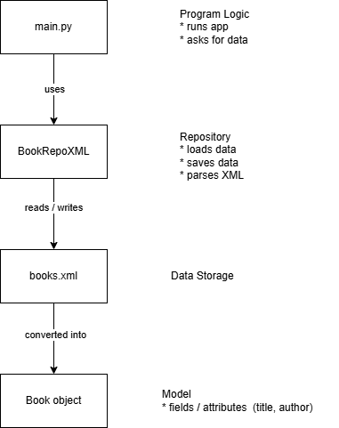

Component Roles

1. bookstore.xml
This is the data file. It stores the book information permanently.
Example XML structure:
<book>
<title>Harry Potter</title>
<author>J.K. Rowling</author>
</book>

2. Book (Model)
The Book class represents one book in memory while the program is running. When the XML file is read, each <book> entry becomes a Book object.

3. BookRepoXml (Repository)
The repository is responsible for interacting with the data file. It reads the XML file, converts entries into Book objects, and saves Book objects back to XML.

4. main.py
The main program controls the application. It creates the repository, asks it to load data, works with the Book objects, and tells the repository to save changes.

Conceptual Diagram
main.py
│
│ requests data
▼
BookRepoXml ───────── reads/writes ─────────► bookstore.xml
│
│ creates
▼
Book objects (title, author)

Simple Analogy and Summary
XML file | Filing cabinet storing information | stored data
Repository | Office worker who knows how to access the cabinet | reads and writes the data
Book object | The document placed on your desk to work with | one record represented as an object
main.py | The manager telling the worker what to do | controls the application

